Test Case: tc006_SPX_Dev5_Crear_Requisicion_Spot_Tipo_Cobro_Proyect_Urgent
Step 1 - Enter username and password and click to button Enter: Credentials Entered
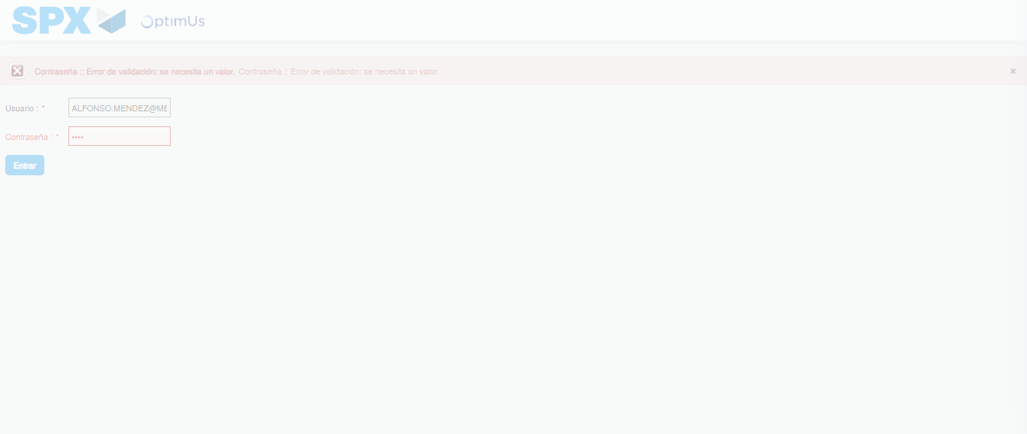Image file-name: QC_Testing-tc006_SPX_Dev5_Crear_Requisicion_Spot_Tipo_Cobro_Proyect_Urgent-1783374763532

Step 2 - Select to UEN and Access to Spot Buy Requisitions : UEN Correctly selected and Correct access
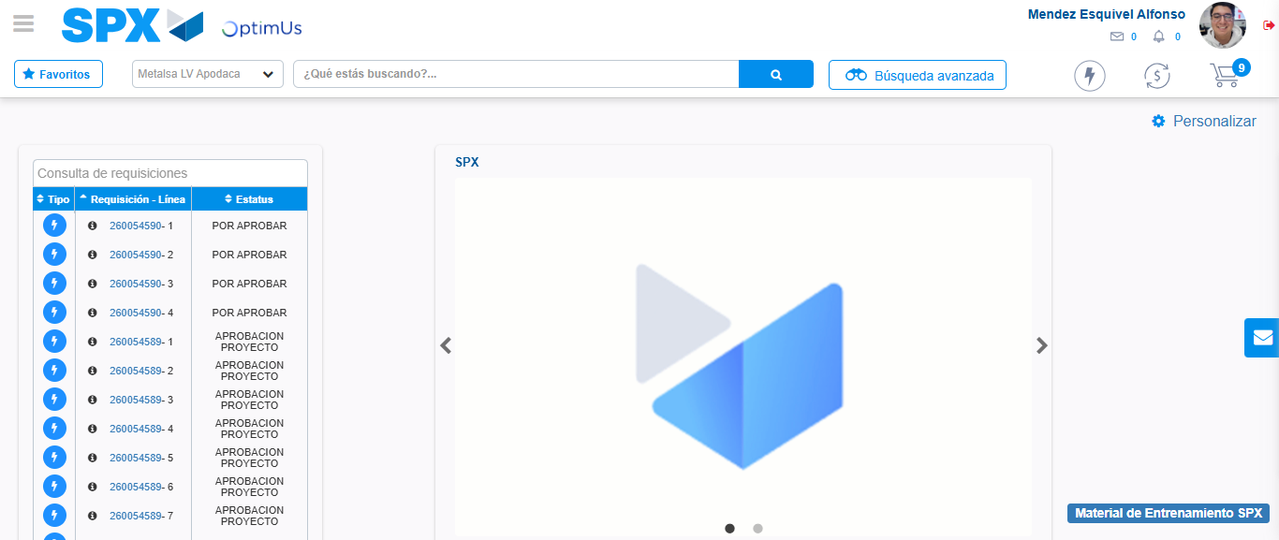Image file-name: QC_Testing-tc006_SPX_Dev5_Crear_Requisicion_Spot_Tipo_Cobro_Proyect_Urgent-1783374789706

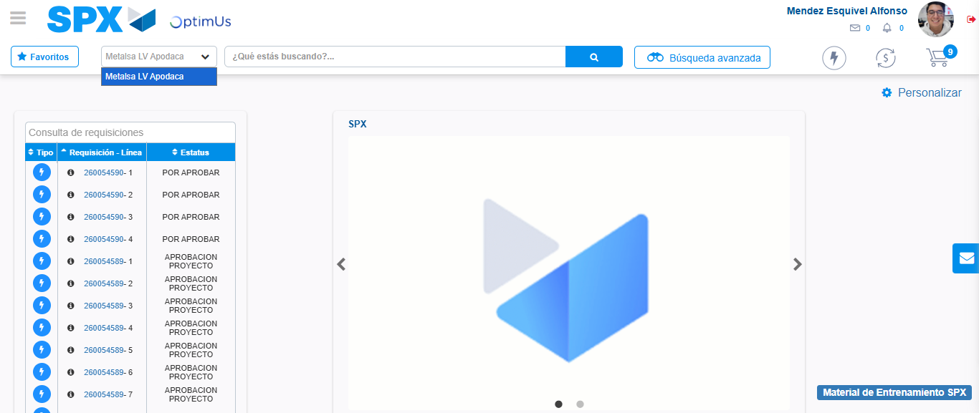Image file-name: QC_Testing-tc006_SPX_Dev5_Crear_Requisicion_Spot_Tipo_Cobro_Proyect_Urgent-1783374792179

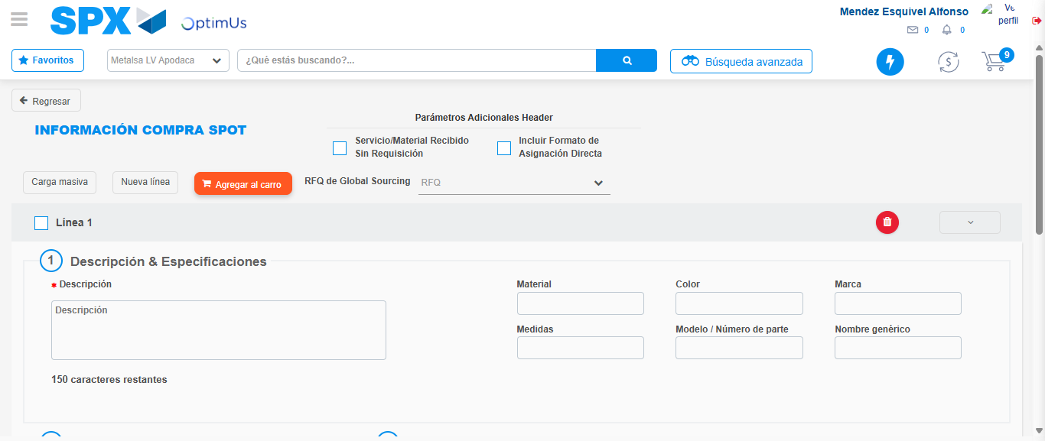Image file-name: QC_Testing-tc006_SPX_Dev5_Crear_Requisicion_Spot_Tipo_Cobro_Proyect_Urgent-1783374815220

Step 3 - Data Capture Spot Buy Requisition: Data captured correctly
Image file-name: QC_Testing-tc006_SPX_Dev5_Crear_Requisicion_Spot_Tipo_Cobro_Proyect_Urgent-1783374815468

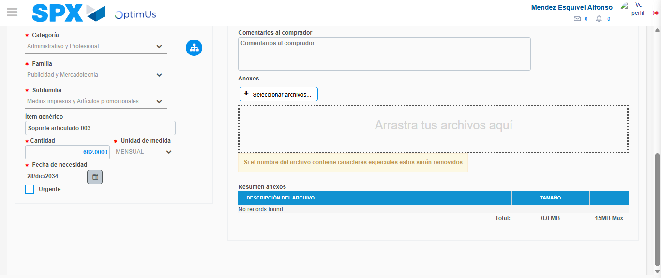Image file-name: QC_Testing-tc006_SPX_Dev5_Crear_Requisicion_Spot_Tipo_Cobro_Proyect_Urgent-1783374826074

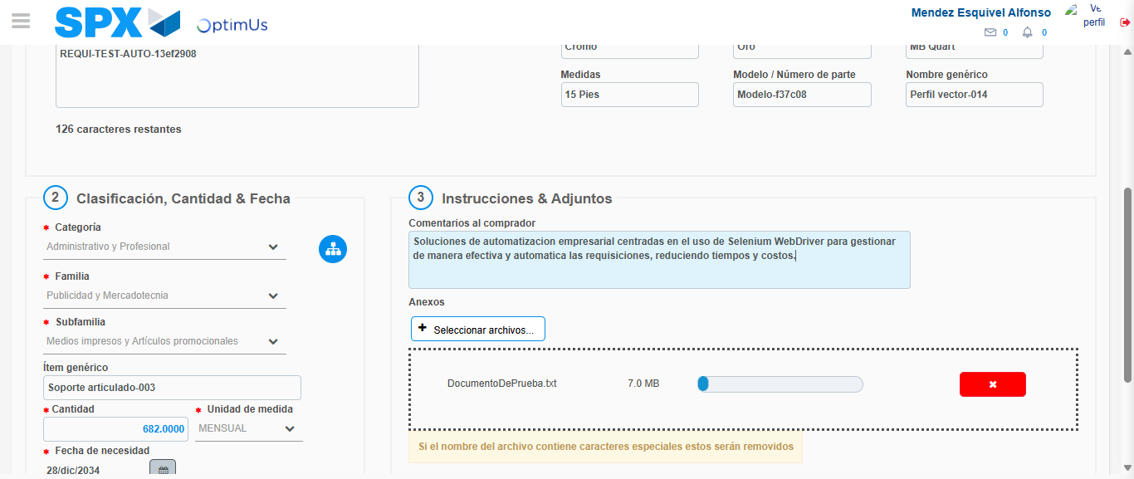Image file-name: QC_Testing-tc006_SPX_Dev5_Crear_Requisicion_Spot_Tipo_Cobro_Proyect_Urgent-1783374826856

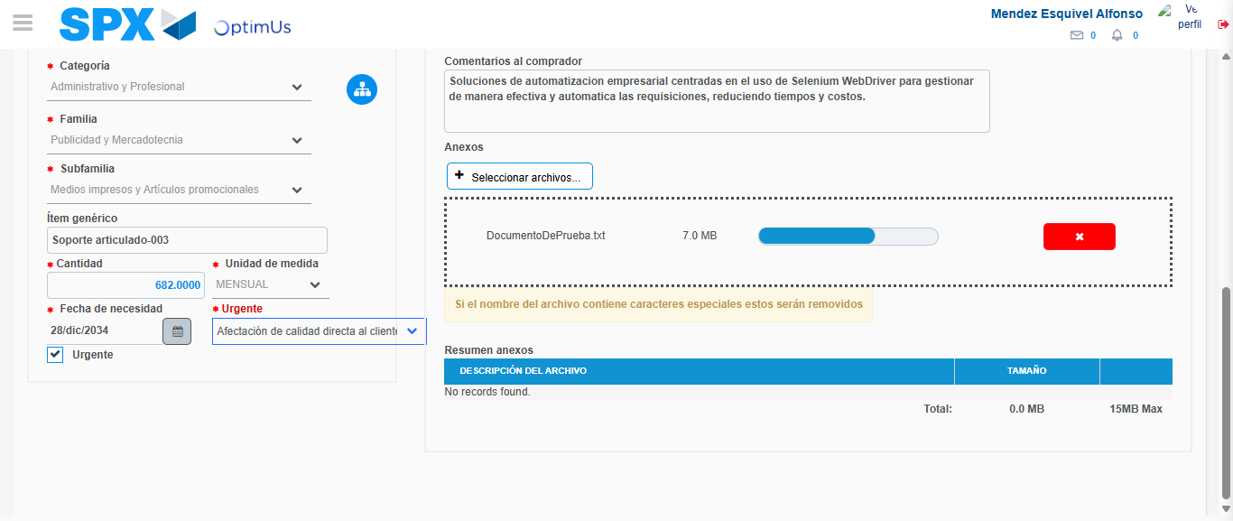Image file-name: QC_Testing-tc006_SPX_Dev5_Crear_Requisicion_Spot_Tipo_Cobro_Proyect_Urgent-1783374830686

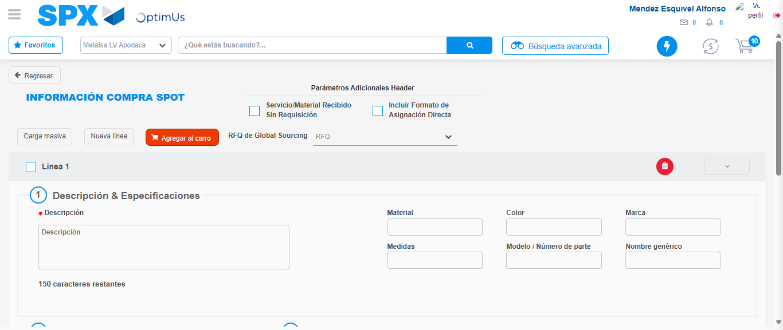Image file-name: QC_Testing-tc006_SPX_Dev5_Crear_Requisicion_Spot_Tipo_Cobro_Proyect_Urgent-1783374836606

Step 7 - Return to Main Page SPX : Return to Main Page SPX
Image file-name: QC_Testing-tc006_SPX_Dev5_Crear_Requisicion_Spot_Tipo_Cobro_Proyect_Urgent-1783374789706

Image file-name: QC_Testing-tc006_SPX_Dev5_Crear_Requisicion_Spot_Tipo_Cobro_Proyect_Urgent-1783374792179

Image file-name: QC_Testing-tc006_SPX_Dev5_Crear_Requisicion_Spot_Tipo_Cobro_Proyect_Urgent-1783374815220

Image file-name: QC_Testing-tc006_SPX_Dev5_Crear_Requisicion_Spot_Tipo_Cobro_Proyect_Urgent-1783374838843

Image file-name: QC_Testing-tc006_SPX_Dev5_Crear_Requisicion_Spot_Tipo_Cobro_Proyect_Urgent-1783374839020

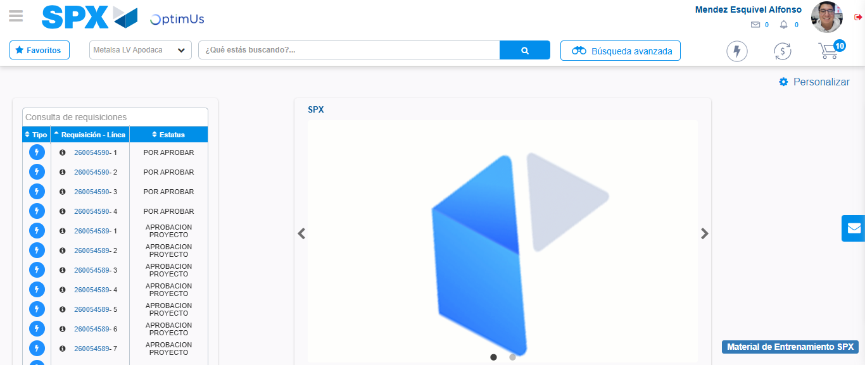Image file-name: QC_Testing-tc006_SPX_Dev5_Crear_Requisicion_Spot_Tipo_Cobro_Proyect_Urgent-1783374860087

Step 8 - Log Out : Log Out SPX
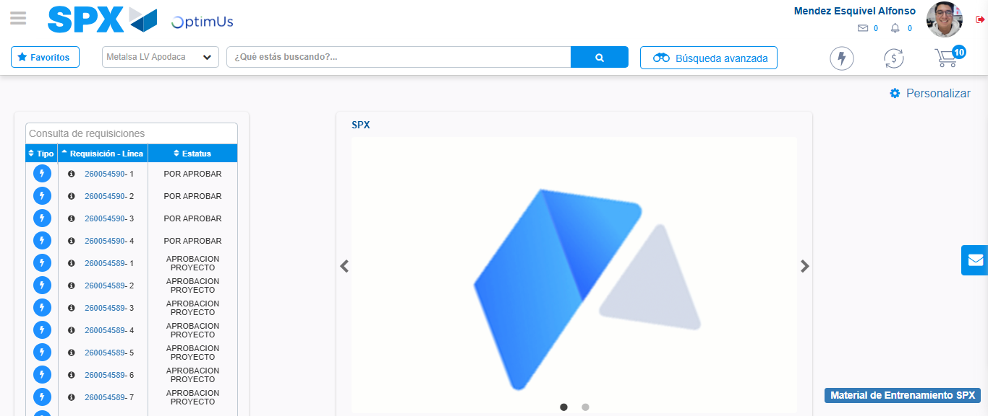Image file-name: QC_Testing-tc006_SPX_Dev5_Crear_Requisicion_Spot_Tipo_Cobro_Proyect_Urgent-1783374860294

